Bios for Global Health

Laeequa Bayat

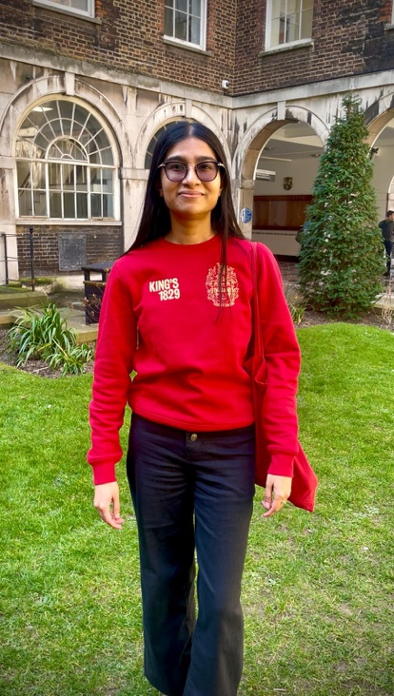

My name is Laeequa Bayat, and I am a South African medical doctor currently completing a Master’s in Public Health at King’s College London as a Chevening Scholar. Having previously obtained a Diploma in HIV Management, I have developed a strong passion for tackling infectious diseases, particularly tuberculosis, which remains a major public health burden in South Africa.

For the CJ Littlejohn’s prize, I co-presented a poster comparing the management of multidrug-resistant tuberculosis (MDR-TB) in Bangladesh and Germany. The project explored how different health systems address the challenges of MDR-TB and what lessons can be shared across contexts. This reflects my wider commitment to advancing infectious disease control and improving outcomes in communities most affected by TB.

Lauren Taylor

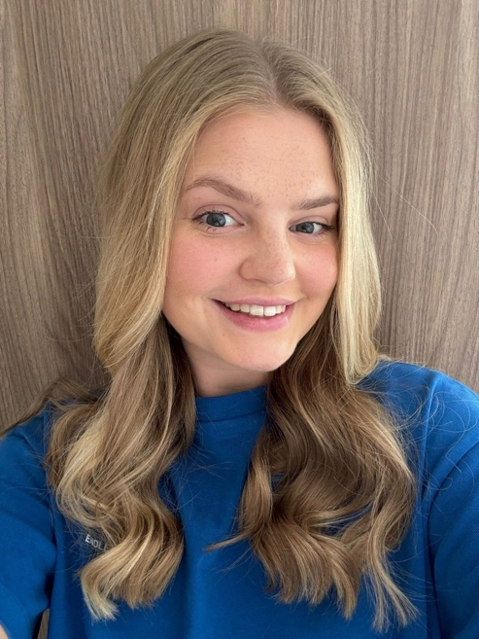

My name is Lauren Taylor. I completed an undergraduate degree at University of York in Biomedical Science and have just completed a Master in Public Health at King’s College London. This degree has provided me with essential knowledge in health promotion, epidemiology and communicable disease prevention. I am particularly passionate about tackling health inequalities both in the UK and globally. In 2022, I volunteered in Ghana where I shadowed doctors in local hospitals and taught English in local schools. I also spent six weeks in Nepal in 2024 where I delivered educational workshops to women and children in the local community of Pokhara. In my free time, I enjoy travelling, cooking and reading.

Isobel Duce

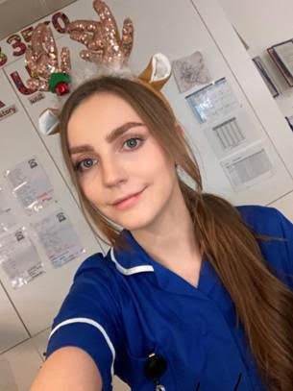

My name is Isobel Duce and I have been a paediatric nurse for four years, after graduating with a BSc from the University of Surrey in 2021. I have gained comprehensive experience through working in multiple areas including a general children’s ward, ambulatory care, and day surgery. Alongside my clinical work, I have been a regular volunteer, including nine years with St John Ambulance and undertaking international volunteer work in an orphanage in Tanzania. Seeing the impact of poor health on children and families first-hand, as well as inequalities across communities, sparked my passion for public and global health. This led to my enrolment in the Master of Public Health programme at King’s College London in 2024. Through a combination of professional, academic, and personal experiences, I have developed a strong interest in improving healthcare services for children and families and aspire to pursue a career in children’s health research after completing my Master’s degree.

Ysobel Trinder

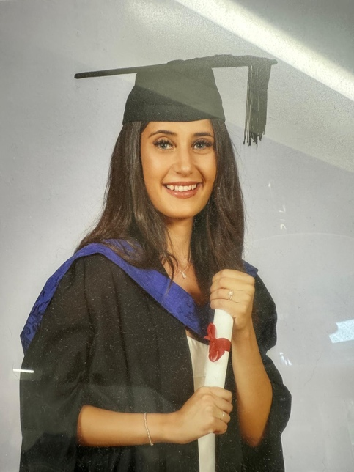

Ysobel is a paediatric nurse with experience caring for babies, children, and young people in clinical settings. She completed her Bachelor’s degree in Child Nursing at the University of Surrey, where she developed a strong passion for improving the health and wellbeing of children and their families. In 2024, Ysobel travelled to South Africa and Tanzania, volunteering in both an orphanage and a local hospital. These experiences reignited her commitment to public and global health, further strengthened through her enjoyment of the global health module within her Master of Public Health programme. She is currently completing her Master’s at King’s College London and aspires to pursue a career in global health upon qualifying.

Jess Mitchell

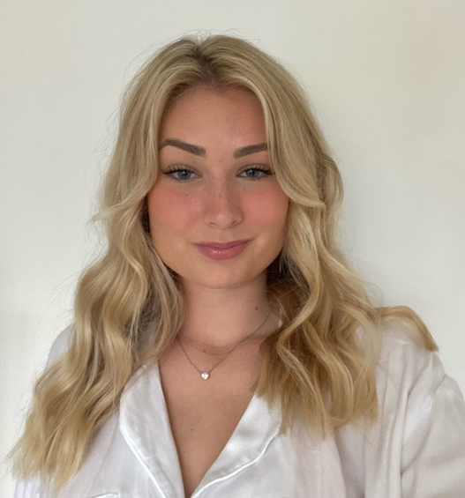

My name is Jess Mitchell and I am completing a Master of Public Health at King’s College London, following an undergraduate degree in International Development and Global Health at the University of Winchester. Alongside my studies, I have worked in the charity sector in roles focused on fundraising, engagement, and education, and co-led the design of a short course on applied research and evaluation for health and social care professionals. I have also volunteered in Zambia, supporting child health and hygiene education, and in Greece, where I lead a small animal welfare charity. These experiences have strengthened my commitment to tackling health inequalities and pursuing a career in global health with a focus on children’s health and equity.

